**Practical-1**

**AIM :- Document Indexing and Retrieval**

1. Implement an inverted index construction algorithm.
2. Build a simple document retrieval system using the constructed index.

**Source Code :-**

document1="The quick brown fox jumped over the lazy dog."

document2="The lazy dog slept in the sun."

tokens1=document1.lower().split()

tokens2=document2.lower().split()

terms=list(set(tokens1+tokens2))

inverted_index={}

**for** term **in** terms:

documents = []

**if** term **in** tokens1:

documents.append("Document 1")

**if** term **in** tokens2:

documents.append("Document 2")

inverted_index[term]=documents

**for** term,documents **in** inverted_index.items():

**print** (term ,"->",",".join(documents))

**Output :-**

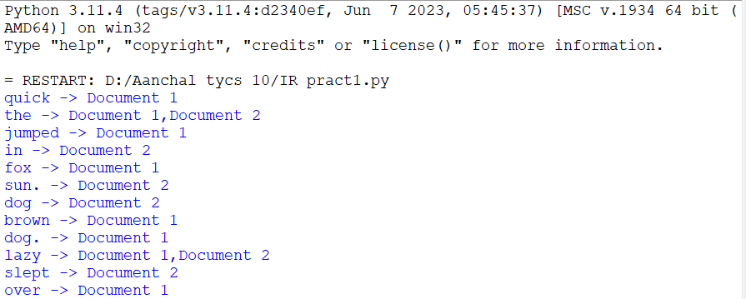

**Practical-2**

**AIM :-** **Retrieval Models**

1. Implement the Boolean retrieval model and process queries.
2. Implement the vector space model with TF-IDF weighting and cosine similarity.

**A)**

**Source Code :-**

documents={

1:"apple banana orange",

2:"apple banana",

3:"banana orange",

4:"apple"

}

**def** build_index(docs):

index={}

**for** doc_id, text **in** docs.items():

terms=set(text.split())

**for** term **in** terms:

**if** term **not** **in** index:

index[term]={doc_id}

**else**:

index[term].add(doc_id)

**return** index

inverted_index=build_index(documents)

**def** boolean_and(operands,index):

**if** **not** operands:

**return** list(range(1,len(documents) +1))

result=index.get(operands[0],set())

**for** term **in** operands[1:]:

result=result.intersection(index.get(term,set()))

**return** list(result)

**def** boolean_or(operands,index):

result=set()

**for** term **in** operands:

result=result.union(index.get(term,set()))

**return** list(result)

**def** boolean_not(operand,index,total_docs):

operand_set=set(index.get(operand,set()))

all_docs_set=set(range(1,total_docs+1))

**return** list(all_docs_set.difference(operand_set))

query1=["apple","banana"]

query2=["apple","orange"]

result1=boolean_and(query1,inverted_index)

result2=boolean_or(query2,inverted_index)

result3=boolean_not("orange",inverted_index , len(documents))

**print**("Documents containing 'apple' and 'banana':",result1)

**print**("Documents containing 'apple' or 'orange':",result2)

**print**("Documents not containing 'orange':",result3)

**Output :-**

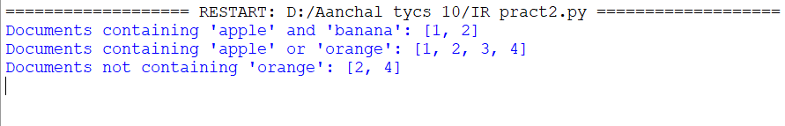

**B)**

**Source Code :-**

**import** math

**from** collections **import** Counter

**def** tokenize(text):

# Simple tokenization, you might want to improve it based on your specific needs

**return** text.lower().split()

**def** compute_tf(doc):

# Computes term frequency (TF) for each term in the document

word_count = Counter(tokenize(doc))

total_words = len(tokenize(doc))

tf = {word: count/total_words **for** word, count **in** word_count.items()}

**return** tf

**def** compute_idf(documents):

# Computes inverse document frequency (IDF) for each term in the collection of documents

N = len(documents)

idf = {}

**for** doc **in** documents:

terms = set(tokenize(doc))

**for** term **in** terms:

idf[term] = idf.get(term, 0) + 1

idf = {term: math.log(N/frequency) **for** term, frequency **in** idf.items()}

**return** idf

**def** compute_tf_idf(tf, idf):

# Computes TF-IDF for each term in the document

tf_idf = {term: tf[term] * idf.get(term, 0) **for** term **in** tf}

**return** tf_idf

**def** compute_cosine_similarity(query_tf_idf, doc_tf_idf):

# Computes cosine similarity between query and document TF-IDF vectors

common_terms = set(query_tf_idf.keys()) & set(doc_tf_idf.keys())

dot_product = sum(query_tf_idf[term] * doc_tf_idf[term] **for** term **in** common_terms)

query_norm = math.sqrt(sum(value**2 **for** value **in** query_tf_idf.values()))

doc_norm = math.sqrt(sum(value**2 **for** value **in** doc_tf_idf.values()))

**if** query_norm == 0 **or** doc_norm == 0:

**return** 0

similarity = dot_product / (query_norm * doc_norm)

**return** similarity

similarity = dot_product / (query_norm * doc_norm)

**return** similarity

**def** vector_space_model(documents, query):

# Build TF-IDF vectors for documents and query

tf_idf_vectors = []

**for** doc **in** documents:

tf = compute_tf(doc)

idf = compute_idf(documents)

tf_idf = compute_tf_idf(tf, idf)

tf_idf_vectors.append(tf_idf)

query_tf = compute_tf(query)

query_idf = compute_idf(documents)

query_tf_idf = compute_tf_idf(query_tf, query_idf)

# Compute cosine similarity between query and each document

similarities = []

**for** doc_tf_idf **in** tf_idf_vectors:

similarity = compute_cosine_similarity(query_tf_idf, doc_tf_idf)

similarities.append(similarity)

**return** similarities

# Example usage:

documents = [

"This is the first document.",

"This document is the document.",

"And this is the third one.",

"Is this the document?",

]

query = "This is a query document."

similarities = vector_space_model(documents, query)

**print**("Cosine Similarities:")

**for** i, sim **in** enumerate(similarities):

**print**(f"Document {i + 1}: {sim}")

**Output :-**

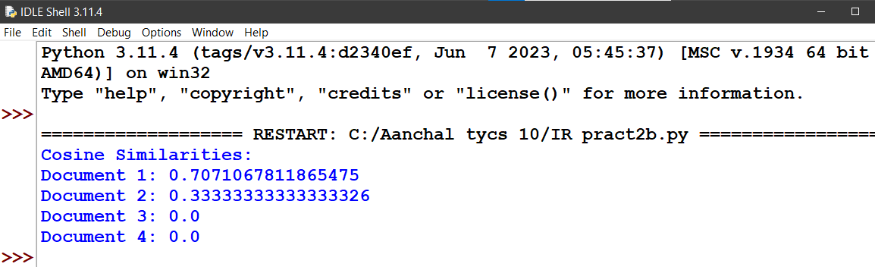

**Practical-3**

**AIM :-** **Spelling Correction in IR Systems**

1. Develop a spelling correction module using edit distance algorithms.
2. Integrate the spelling correction module into an information retrieval system.

**Source Code :-**

**def** edit_distance(str1, str2):

m, n = len(str1), len(str2)

dp = [[0] * (n + 1) **for** _ **in** range(m + 1)]

**for** i **in** range(m + 1):

**for** j **in** range(n + 1):

**if** i == 0:

dp[i][j] = j

**elif** j == 0:

dp[i][j] = i

**elif** str1[i-1] == str2[j-1]:

dp[i][j] = dp[i-1][j-1]

**else**:

dp[i][j] = 1 + min(dp[i][j-1], # Insert

dp[i-1][j], # Remove

dp[i-1][j-1] # Replace

)

**return** dp[m][n]

**def** correct_spelling(query, dictionary):

corrected_query = query.lower() # Convert to lowercase for case-insensitive correction

suggestions = []

**for** word **in** dictionary:

distance = edit_distance(corrected_query, word.lower())

**if** distance <= 10: # You can adjust this threshold based on your preference

suggestions.append((word, distance))

suggestions.sort(key=**lambda** x: x[1]) # Sort by distance in ascending order

**return** suggestions

# Example usage

dictionary = ["information", "retrieval", "spelling", "correction", "system"]

query = input("Enter your query: ")

suggestions = correct_spelling(query, dictionary)

**if** suggestions:

**print**("Did you mean:")

**for** suggestion, distance **in** suggestions:

**print**(f"{suggestion} (Edit Distance: {distance})")

**else**:

**print**("No suggestions found.")

**Output :-**

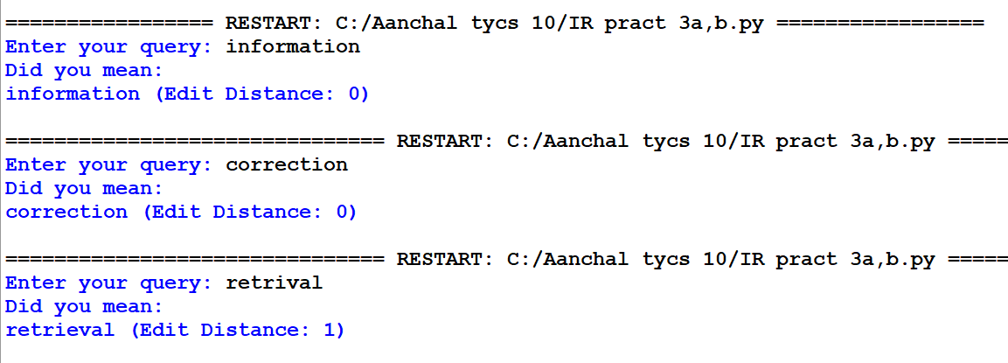

**Practical-4**

**AIM :- Evaluation Metrics for IR Systems**

1. Calculate precision, recall, and F-measure for a given set of retrieval results.
2. Use an evaluation toolkit to measure average precision and other evaluation metrics.

**A)**

**Source Code :-**

**def** calculate_metrics(retrieved_set, relevant_set):

true_positive = len(retrieved_set.intersection(relevant_set))

false_positive = len(retrieved_set.difference(relevant_set))

false_negative = len(relevant_set.difference(retrieved_set))

**print**("True Positive: ", true_positive,

"\nFalse Positive: ", false_positive,

"\nFalse Negative: ", false_negative, "\n")

precision = true_positive / (true_positive + false_positive)

recall = true_positive / (true_positive + false_negative)

f_measure = 2 * precision * recall / (precision + recall)

**return** precision, recall, f_measure

retrieved_set = set(["doc1", "doc2", "doc3"]) # Predicted set

relevant_set = set(["doc1", "doc4"]) # Actually Needed set (Relevant)

precision, recall, f_measure = calculate_metrics(retrieved_set, relevant_set)

**print**(f"Precision: {precision}")

**print**(f"Recall: {recall}")

**print**(f"F-measure: {f_measure}")

**Output :-**

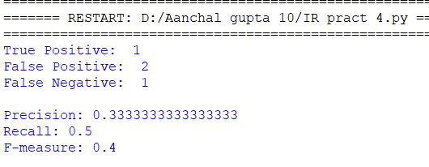

**B)**

**Source Code :-**

**from** sklearn.metrics **import** average_precision_score, precision_recall_curve, auc

**from** sklearn.metrics **import** accuracy_score, precision_score, recall_score, f1_score, roc_auc_score

**import** matplotlib.pyplot **as** plt

**import** numpy **as** np

**def** calculate_classification_metrics(y_true, y_pred_prob):

"""

Calculate various classification metrics.

Parameters:

- y_true: True labels (ground truth).

- y_pred_prob: Predicted probabilities for the positive class.

Returns:

- Dictionary containing different evaluation metrics.

"""

# Convert probabilities to binary predictions

y_pred_binary = (np.array(y_pred_prob) >= 0.5).astype(int)

# Accuracy

accuracy = accuracy_score(y_true, y_pred_binary)

# Precision, Recall, F1 Score

precision = precision_score(y_true, y_pred_binary)

recall = recall_score(y_true, y_pred_binary)

f1 = f1_score(y_true, y_pred_binary)

# ROC-AUC

roc_auc = roc_auc_score(y_true, y_pred_prob)

# Average Precision and Precision-Recall curve

average_precision = average_precision_score(y_true, y_pred_prob)

precision_curve, recall_curve, _ = precision_recall_curve(y_true, y_pred_prob)

area_under_pr_curve = auc(recall_curve, precision_curve)

# Print metrics

**print**(f'Accuracy: {accuracy}')

**print**(f'Precision: {precision}')

**print**(f'Recall: {recall}')

**print**(f'F1 Score: {f1}')

**print**(f'ROC-AUC: {roc_auc}')

**print**(f'Average Precision: {average_precision}')

**print**(f'Area under Precision-Recall curve: {area_under_pr_curve}')

# Plot Precision-Recall curve

plt.figure(figsize=(8, 6))

plt.plot(recall_curve, precision_curve, color='blue', lw=2, label='Precision-Recall curve')

plt.xlabel('Recall')

plt.ylabel('Precision')

plt.title('Precision-Recall Curve')

plt.legend()

plt.show()

# Example usage:

# Replace the following placeholders with your actual data

# Example for binary classification

y_true_binary = [1, 0, 1, 0, 1] # True binary labels (1 for positive, 0 for negative)

y_pred_prob_binary = [0.8, 0.6, 0.9, 0.5, 0.7] # Predicted probabilities for the positive class

calculate_classification_metrics(y_true_binary, y_pred_prob_binary)

**Output :-**

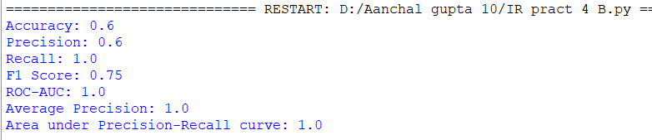

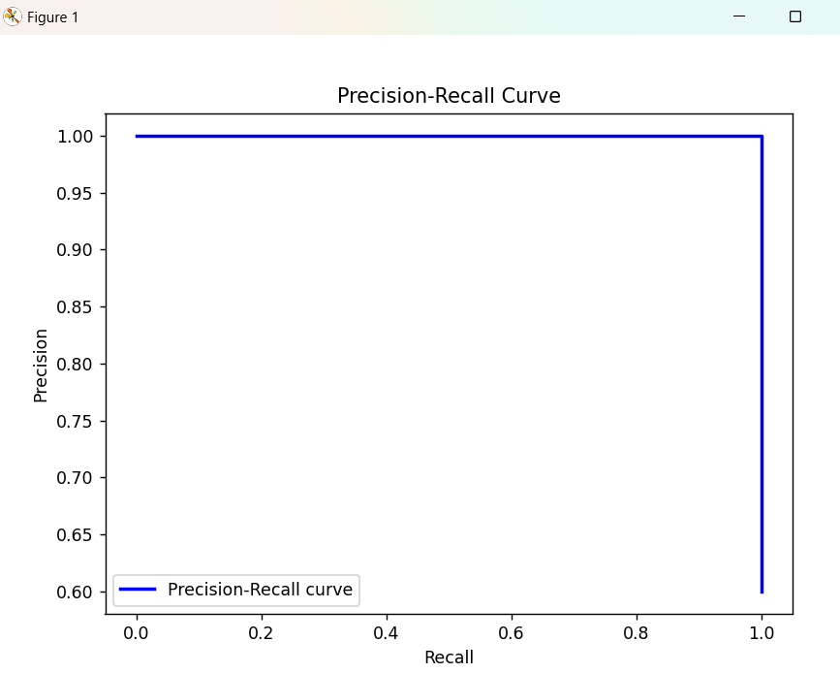

**Practical-5**

**AIM :- Text Categorization**

1. Implement a text classification algorithm (e.g., Naive Bayes or Support Vector Machines).
2. Train the classifier on a labelled dataset and evaluate its performance.

**Source Code :-**

# Import necessary libraries

**from** sklearn.datasets **import** fetch_20newsgroups

**from** sklearn.feature_extraction.text **import** TfidfVectorizer

**from** sklearn.model_selection **import** train_test_split

**from** sklearn.svm **import** SVC

**from** sklearn.metrics **import** accuracy_score, classification_report

# Load the 20 Newsgroups dataset

newsgroups = fetch_20newsgroups(subset='all', remove=('headers', 'footers', 'quotes'))

# Split the dataset into training and testing sets

X_train, X_test, y_train, y_test = train_test_split(newsgroups.data, newsgroups.target, test_size=0.2, random_state=42)

# Convert text data to TF-IDF features

vectorizer = TfidfVectorizer()

X_train_tfidf = vectorizer.fit_transform(X_train)

X_test_tfidf = vectorizer.transform(X_test)

# Train a Support Vector Machine (SVM) classifier

svm_classifier = SVC(kernel='linear', C=1.0)

svm_classifier.fit(X_train_tfidf, y_train)

# Make predictions on the test set

y_pred = svm_classifier.predict(X_test_tfidf)

# Evaluate the performance of the classifier

accuracy = accuracy_score(y_test, y_pred)

classification_rep = classification_report(y_test, y_pred, target_names=newsgroups.target_names)

# Print the results

**print**(f"Accuracy: {accuracy:.2f}")

**print**("\nClassification Report:")

**print**(classification_rep)

**Output :-**

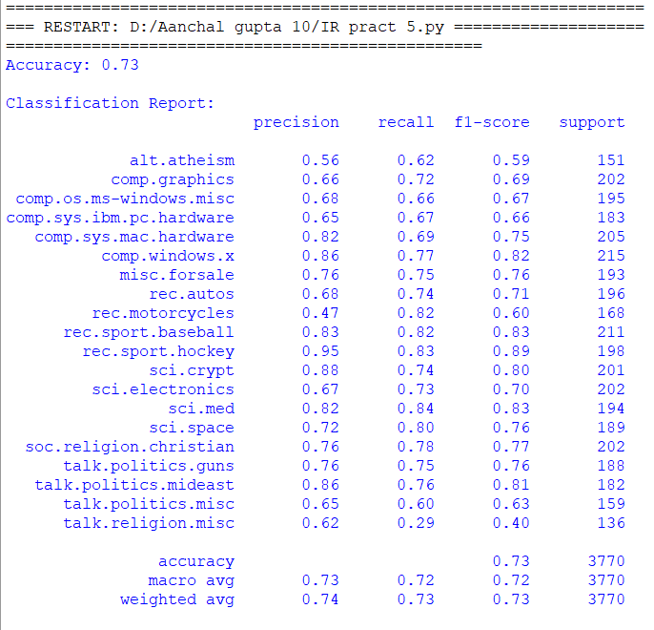

**Practical-6**

**AIM :- Clustering for Information Retrieval**

1. Implement a clustering algorithm (e.g., K-means or hierarchical clustering).
2. Apply the clustering algorithm to a set of documents and evaluate the clustering results.

**Source Code :-**

# Import necessary libraries

**from** sklearn.feature_extraction.text **import** TfidfVectorizer

**from** sklearn.cluster **import** KMeans

**from** sklearn.metrics **import** silhouette_score

# Sample documents

documents = [

"This is the first document.",

"This document is the second document.",

"And this is the third one.",

"Is this the first document?",

"The last document is here."

]

# Convert documents to TF-IDF matrix

vectorizer = TfidfVectorizer()

X = vectorizer.fit_transform(documents)

# Apply K-means clustering

num_clusters = 2 # You can adjust the number of clusters as needed

n_init_value = 10 # You can adjust this value based on your needs

kmeans = KMeans(n_clusters=num_clusters, n_init='auto')

kmeans.fit(X)

# Get cluster labels

cluster_labels = kmeans.labels_

# Calculate silhouette score using the original documents and cluster labels

silhouette_avg = silhouette_score(X, cluster_labels)

# Print results

**print**("Cluster labels:", cluster_labels)

**print**("Silhouette Score:", silhouette_avg)

**Output :-**

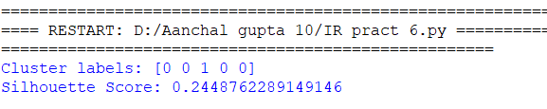

**Practical-7**

**AIM :- Web Crawling and Indexing**

1. Develop a web crawler to fetch and index web pages.
2. Handle challenges such as robots.txt, dynamic content, and crawling delays.

**Source Code :-**

**import** requests

**from** bs4 **import** BeautifulSoup

**import** time

**from** urllib.parse **import** urlparse, urljoin

**from** urllib.robotparser **import** RobotFileParser

**class** WebCrawler:

**def** __init__(self, seed_url, max_pages=100):

self.seed_url = seed_url

self.base_url = urlparse(seed_url).scheme + '://' + urlparse(seed_url).hostname

self.visited_urls = set()

self.queue = [seed_url]

self.max_pages = max_pages

self.pages_crawled = 0

self.robot_parser = RobotFileParser()

self.robot_parser.set_url(urljoin(self.base_url, '/robots.txt'))

self.robot_parser.read()

**def** is_allowed_by_robots(self, url):

**return** self.robot_parser.can_fetch('*', url)

**def** crawl(self):

**while** self.queue **and** self.pages_crawled < self.max_pages:

current_url = self.queue.pop(0)

**if** current_url **not** **in** self.visited_urls **and** self.is_allowed_by_robots(current_url):

**try**:

response = requests.get(current_url)

**if** response.status_code == 200:

soup = BeautifulSoup(response.text, 'html.parser')

# Here you can implement your indexing logic

# For example, extract text, store in a database, etc.

**print**(f"Crawled: {current_url}")

# Extract links from the page and add them to the queue

**for** link **in** soup.find_all('a', href=True):

new_url = urljoin(current_url, link['href'])

**if** new_url.startswith(self.base_url) **and** new_url **not** **in** self.visited_urls:

self.queue.append(new_url)

self.visited_urls.add(current_url)

self.pages_crawled += 1

**except** Exception **as** e:

**print**(f"Error crawling {current_url}: {str(e)}")

# Introduce a delay to avoid being too aggressive

time.sleep(1)

**if** __name__ == "__main__":

seed_url = "https://www.youtube.com/"

max_pages_to_crawl = 10

crawler = WebCrawler(seed_url, max_pages_to_crawl)

crawler.crawl()

**Output :-**

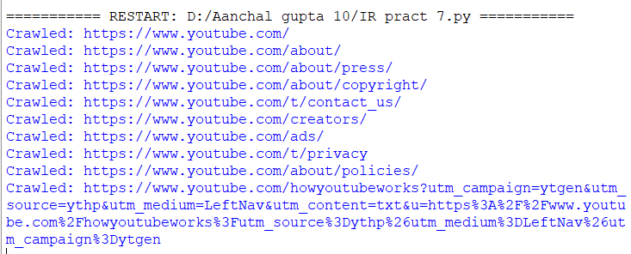

**Practical-8**

**AIM :- Link Analysis and PageRank**

1. Implement the PageRank algorithm to rank web pages based on link analysis.
2. Apply the PageRank algorithm to a small web graph and analyze the results.

**Source Code :-**

**import** numpy **as** np

**def** pagerank(graph, damping_factor=0.85, max_iterations=100, epsilon=1e-8):

num_pages = len(graph)

initial_page_rank = np.ones(num_pages) / num_pages

teleportation_prob = (1 - damping_factor) / num_pages

page_rank = initial_page_rank.copy()

**for** _ **in** range(max_iterations):

prev_page_rank = page_rank.copy()

**for** i **in** range(num_pages):

incoming_links = np.where(graph[:, i] == 1)[0]

sum_page_rank = np.sum(prev_page_rank[incoming_links] / len(incoming_links)) **if** incoming_links.size > 0 **else** 0

page_rank[i] = teleportation_prob + damping_factor * sum_page_rank

# Check for convergence

**if** np.linalg.norm(page_rank - prev_page_rank, 1) < epsilon:

**break**

**return** page_rank

**if** __name__ == "__main__":

# Example web graph (adjacency matrix)

web_graph = np.array([

[0, 1, 1, 1],

[1, 0, 0, 0],

[1, 1, 0, 1],

[0, 0, 1, 0]

])

# Calculate PageRank

page_rank_scores = pagerank(web_graph)

# Display results

**for** i, score **in** enumerate(page_rank_scores):

**print**(f"Page {i + 1}: PageRank Score = {score:.4f}")

**Output :-**

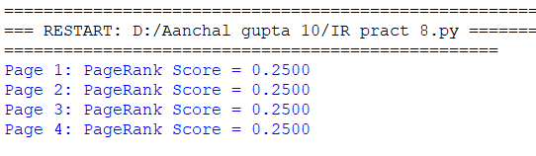

**Practical-9**

**AIM :- Learning to Rank**

1. Implement a learning to rank algorithm (e.g., RankSVM or RankBoost).
2. Train the ranking model using labelled data and evaluate its effectiveness.

**Source Code :-**

**from** sklearn.datasets **import** make_classification

**from** sklearn.model_selection **import** train_test_split

**from** sklearn.preprocessing **import** StandardScaler

**from** sklearn.svm **import** SVC

**from** sklearn.metrics **import** ndcg_score

# Generate synthetic labeled data (replace with your actual labeled data)

X, y = make_classification(n_samples=1000, n_features=10, n_classes=2, random_state=42)

# Split data into train and test sets

X_train, X_test, y_train, y_test = train_test_split(X, y, test_size=0.2, random_state=42)

# Normalize features

scaler = StandardScaler()

X_train_scaled = scaler.fit_transform(X_train)

X_test_scaled = scaler.transform(X_test)

# Train RankSVM model

ranksvm_model = SVC(kernel='linear')

ranksvm_model.fit(X_train_scaled, y_train)

# Predict rankings on test set

y_pred = ranksvm_model.decision_function(X_test_scaled)

# Evaluate model effectiveness using NDCG (Normalized Discounted Cumulative Gain)

ndcg = ndcg_score(y_test.reshape(1, -1), y_pred.reshape(1, -1))

**print**("NDCG Score:", ndcg)

**Output :-**

